

**FPT International School**

--- o0o ---

**PROJECT REPORT**

**Y Van Hien**

**Hanoi - 08/2021**

| **Team Bigboss** | |
| --- | --- |
| **Group Member** | Leader: Tran Tuan Nghia _ TH1905018  Member: Nguyen Thi Nhan _ TH1906004  Member: Nguyen Van Anh _ TH1906001  Member: Mai Thi Thuy Linh _ TH1907021  Member: Hoang TRong Ha_ TH1907023 |
| **Batch** | T1907M |
| **Center** | Fpt Aptech |
| **Semester** | IV |

Table of Contents

**I. Problem Definition** **2**

Introduction 2

Implementation Environment 3

User classes 3

Admin 3

Register 3

Manage Events 3

Manage Categories 3

Manage Products 3

Manage Users 4

Decentralization 4

Customer 4

**II. Database** **5**

DB Relationship Diagram 5

Table 5

Admin 5

Customer 5

Product 6

Categories 6

Order_Detail 7

Rent 7

Rent_Detail 7

**III. Design** **8**

Class Diagram 8

Sequence Diagram 8

a. Login 8

b. Register 9

c. Buy and Rental 11

d. Dress rental 12

Use case diagram 13

**IV. UI/UX** **14**

Home 14

Introduce 15

Product 16

Contact 17

Payment 18

Customer information 19

Cart 20

Order Success 21

Order detail 22

Gallery & Lookbook 22

Admin Dashboard 24

Admin order detail 24

Admin Product 25

List order 26

Categories 27

**V. Management and Project Planning** **27**

Management Approach 27

Project Plan 27

Product Backlog 28

Sprint Backlog 29

Retrospective 32

Meeting minutes 32

# I. Problem Definition

## Introduction

Restore the lost traditional culture of the country

In efforts to restore the lost traditional culture of the country, the website Ỷ Van Hien – Co Phuc Viet Nam was born. Vietnam's traditional culture, consisting of thousands of years of condensed quintessence, is something to be cherished. We believe that understanding the past is the only way to understand the present and beyond will find a direction in the future.

With a team of young professionals, with knowledge, enthusiasm, and creativity, Ỷ Van Hien conducts in-depth research in the fields of art (literature, music, architecture, painting, sculpture), costumes, cuisine, and traditional rituals in the court and folk to commercialize, serve universally for tourism and the community, helping those beauties reach the public at home and abroad.

**Requirement Specification:**

The Web site is to be created based on the following requirements.

1. The home page must be designed with beautiful color combination with all the required links defined properly. Also all the section of the webpage must be in used to avoid the blank space.

2. The functions in the website must be usable, good user experience, avoid the confusion of interface and user experience.

3. About us, Contact Us, Shop, Blog, Program must be included.

4. The Dashboard page shows graphs of statistical data and detailed charts

5. Module management pages corresponding to the topic

## Implementation Environment

• HTML/SCSS

• Vuejs

• PostgreSql

• Java

## User classes

### Admin

#### Register

As an admin, I want to register to access the database.

* *Sign In*

As an admin, I want to login to access the database.

#### Manage Events

As an admin, I want to add, remove and update event for my website.

#### Manage Categories

As an admin, I want to add, remove and update Categories for my website.

#### Manage Products

As an admin, I want to add, remove and update Products for my website.

#### Manage Users

As an admin, I want to add, remove and update users who register to login my website.

#### Decentralization

As an admin, I want to assign other admins to manage separately according to the list, other admins cannot access the non-authorized lists.

* Manage sales statistics

As admin I can manage product sales statistics by day, month, year.

### Customer

* Search for products, items

As a customer, I want to find Products or be able to rent and buy products for myself.

* View products, product details

As a customer, I want to see detailed information about your product to consider buying or not.

* Buy, Rent product

As a customer, I want to buy your product, the product can change the product quantity and see my transaction total.

* Read Blogs, Programs

As a customer, I want to read your Blog, Program, can change the number of services, and see my transaction total.

# II. Database

## DB Relationship Diagram

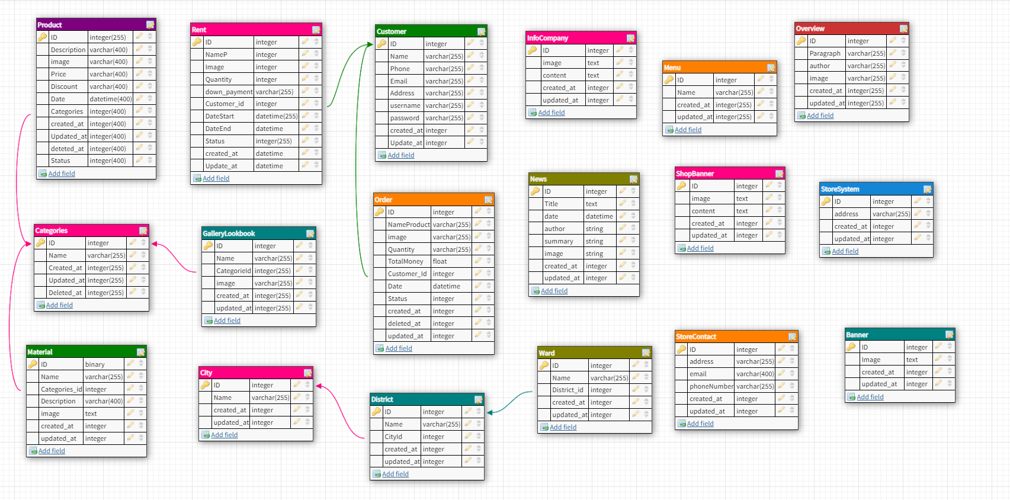

## Table

### Admin

| **Column Name** | **Data Type** | **Constraint** | **Description** |
| --- | --- | --- | --- |
| ID | Int | PK | Primary key of the table |
| Name | Varchar(255) | Not null | Name of admin |
| Image | Varchar(255) | Nullable | Image of admin |
| Phone | Varchar(255) | Not null | Phone of admin |
| User Name | Varchar(255) | Not null | The user name of admin |
| Password | Varchar(255) | Not null | The password of admin |
| Email | Varchar(255) | Not null | The email of admin |
| Address | Varchar(255) | Nullable | Address of admin |

### Customer

| **Column Name** | **Data Type** | **Constraint** | **Description** |
| --- | --- | --- | --- |
| ID | Int | PK | Primary key of the table |
| Name | Varchar(255) | Not null | Name of Customer |
| Image | Varchar(255) | Nullable | Image of Customer |
| Phone | Varchar(255) | Not null | Phone of Customer |
| User Name | Varchar(255) | Not null | User name of customer |
| Password | Varchar(255) | Not null | The password of Customer |
| Email | Varchar(255) | Not null | The email of Customer |
| Address | Varchar(255) | Nullable | Address of Customer |

### Product

| **Column Name** | **Data Type** | **Constraint** | **Description** |
| --- | --- | --- | --- |
| ID | Int | PK | Primary key of the table |
| Name | Varchar(255) | Not null | Name of Product |
| Image | Varchar(255) | Nullable | Image of Product |
| Description | Varchar(255) | Not null | Description of Product |
| Price | Varchar(255) | Not null | The price of Product |
| Discount | Varchar(255) | Not null | The discount of Product |
| Categories | Varchar(255) | Not null | Categories of Product |
| Date | Datetime | Nullable | Date of admin |

### Categories

| **Column Name** | **Data Type** | **Constraint** | **Description** |
| --- | --- | --- | --- |
| ID | Int | PK | Primary key of the table |
| Name | Varchar(255) | Not null | Name of Categories |
| Image | Varchar(255) | Nullable | Image of Categories |

1. Order

| **Column Name** | **Data Type** | **Constraint** | **Description** |
| --- | --- | --- | --- |
| ID | Int | PK | Primary key of the table |
| Name | Varchar(255) | Not null | Name of order |
| Image | Varchar(255) | Nullable | Image of order |
| Quantity | Varchar(255) | Not null | The quantity of order |
| TotalMoney | Float | Not null | The totalmoney of order |
| Customer_id | Int | Not null | Customer_id of customer |
| date | Date time | Not null | Date of order |

### Order_Detail

| **Column Name** | **Data Type** | **Constraint** | **Description** |
| --- | --- | --- | --- |
| ID | Int | PK | Primary key of the table |
| Product_id | Int | Not null | Product_id of product |
| Order_id | Int | Nullable | Order_id of order |
| Message | Varchar(255) | Not null | The message of order_detail |

### Rent

| **Column Name** | **Data Type** | **Constraint** | **Description** |
| --- | --- | --- | --- |
| ID | Int | PK | Primary key of the table |
| Name | Varchar(255) | Not null | Name of Rent |
| Image | Varchar(255) | Nullable | Image of Rent |
| Quantity | Varchar(255) | Not null | The quantity of Rent |
| Down_payment | Varchar(255) | Not null | The down_payment of Rent |
| Customer_id | Int | Not null | Customer_id of Customer |
| Date | Date time | Nullable | Address of customer |

### Rent_Detail

| **Column Name** | **Data Type** | **Constraint** | **Description** |
| --- | --- | --- | --- |
| ID | Int | PK | Primary key of the table |
| Product_id | Int | Not null | Name of admin |
| Rent_id | Int | Not null | Image of admin |
| Message | Varchar(255) | Not null | The password of admin |

# III. Design

## Class Diagram

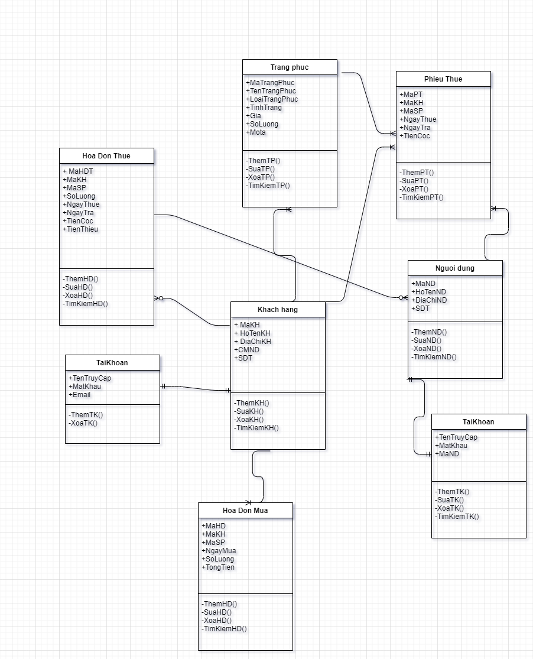

## Sequence Diagram

### a. Login

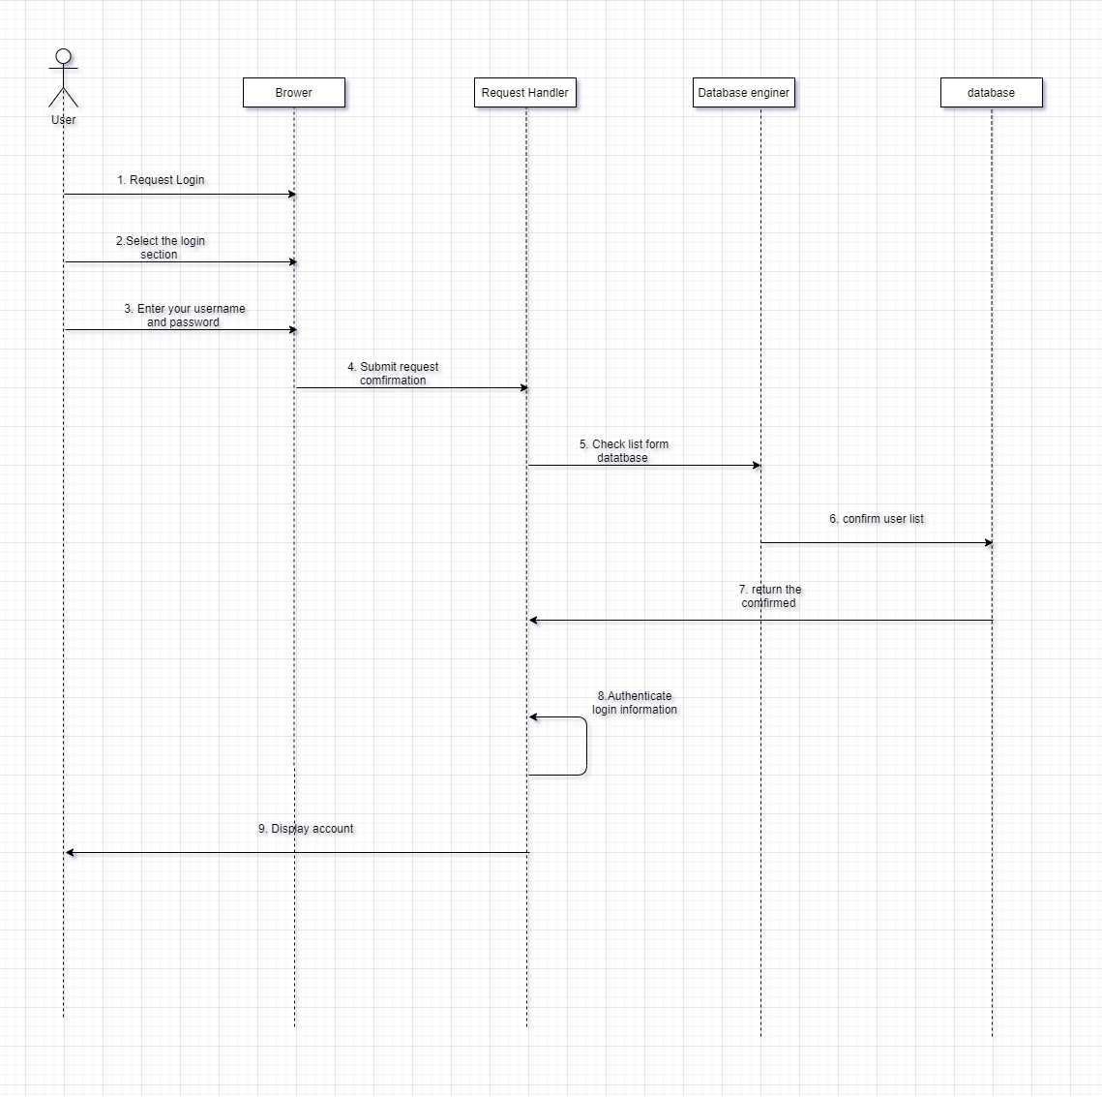

### b. Register

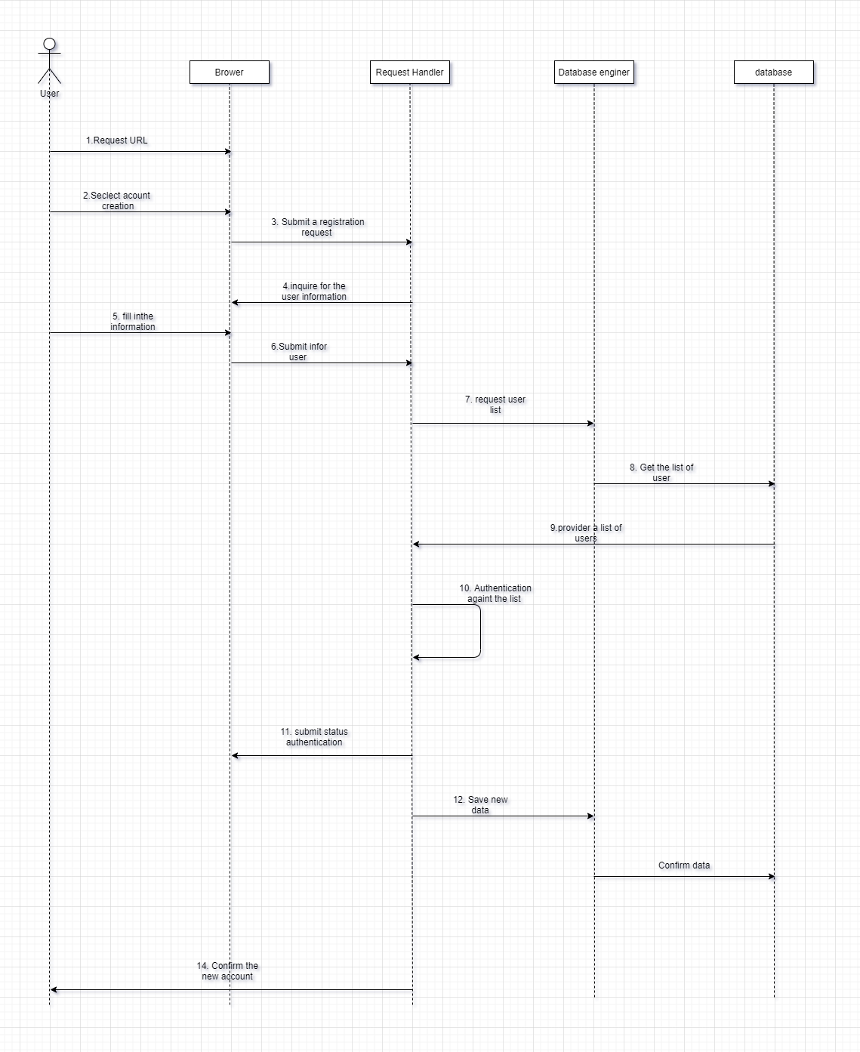

### c. Buy and Rental

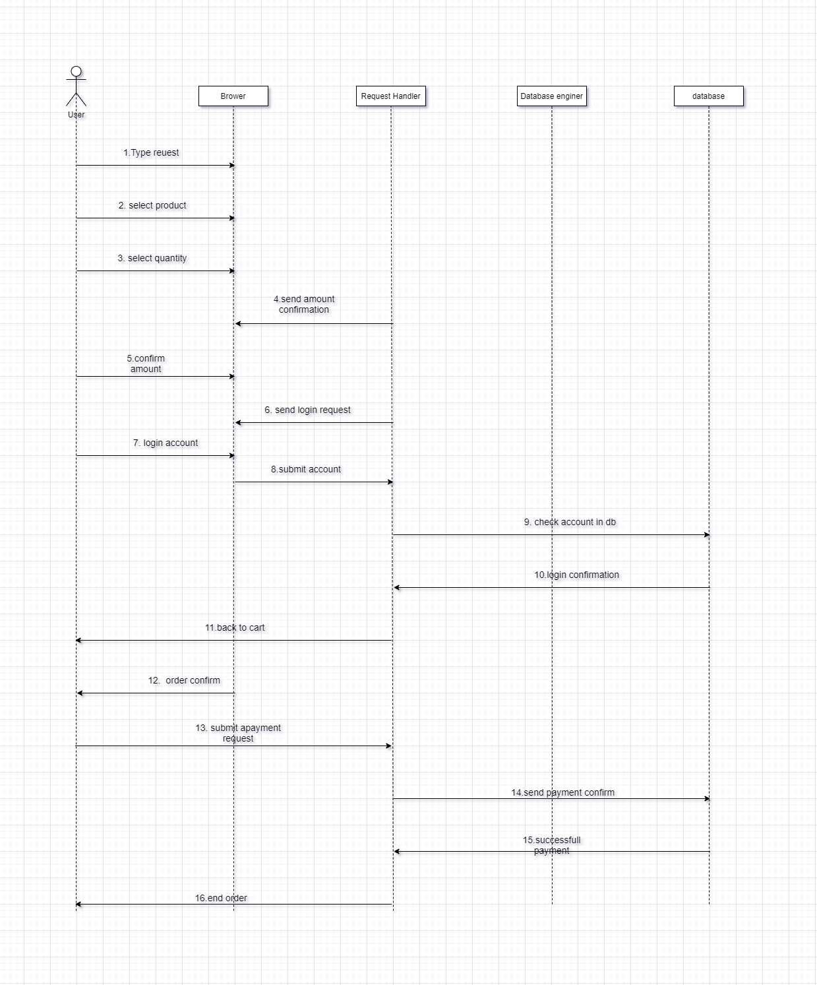

### d. Dress rental

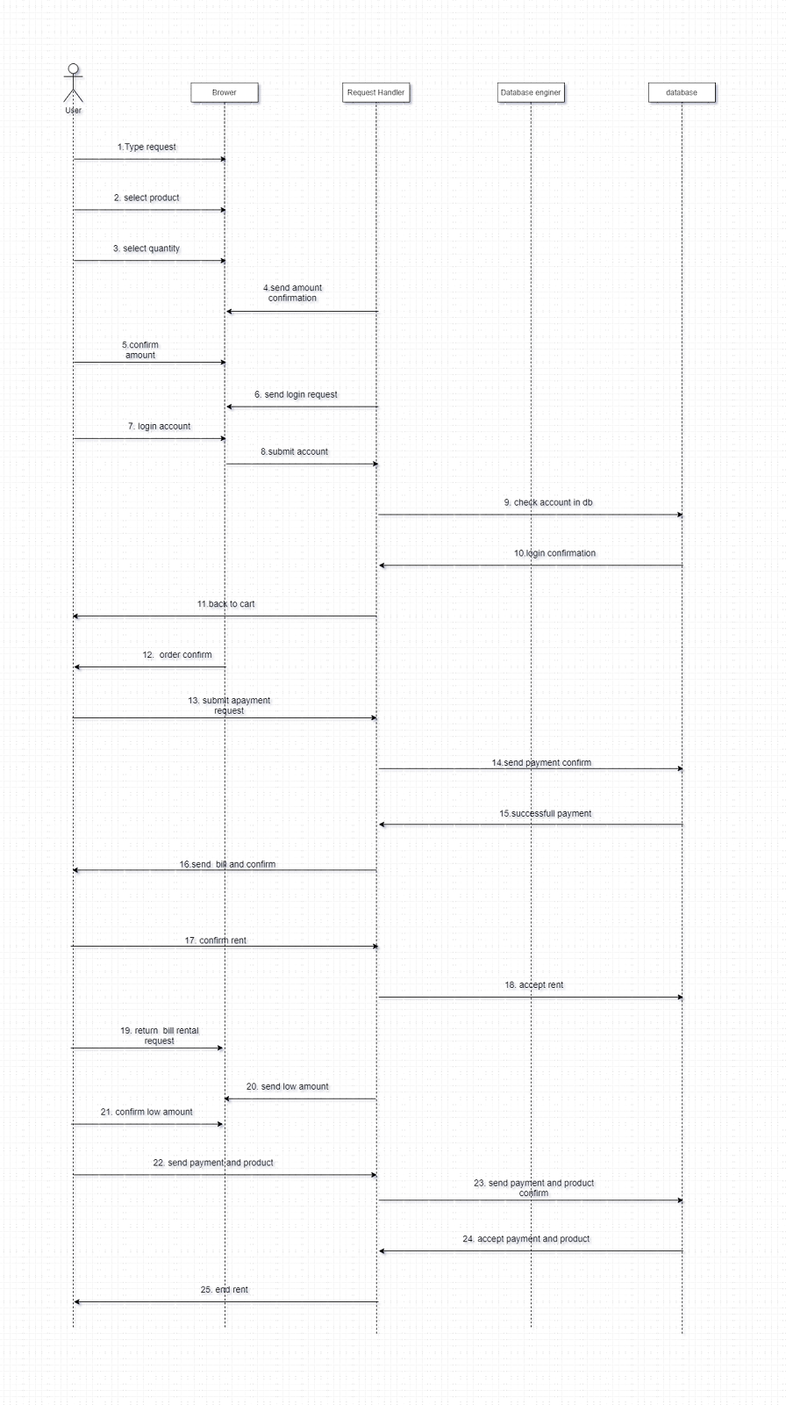

## Use case diagram

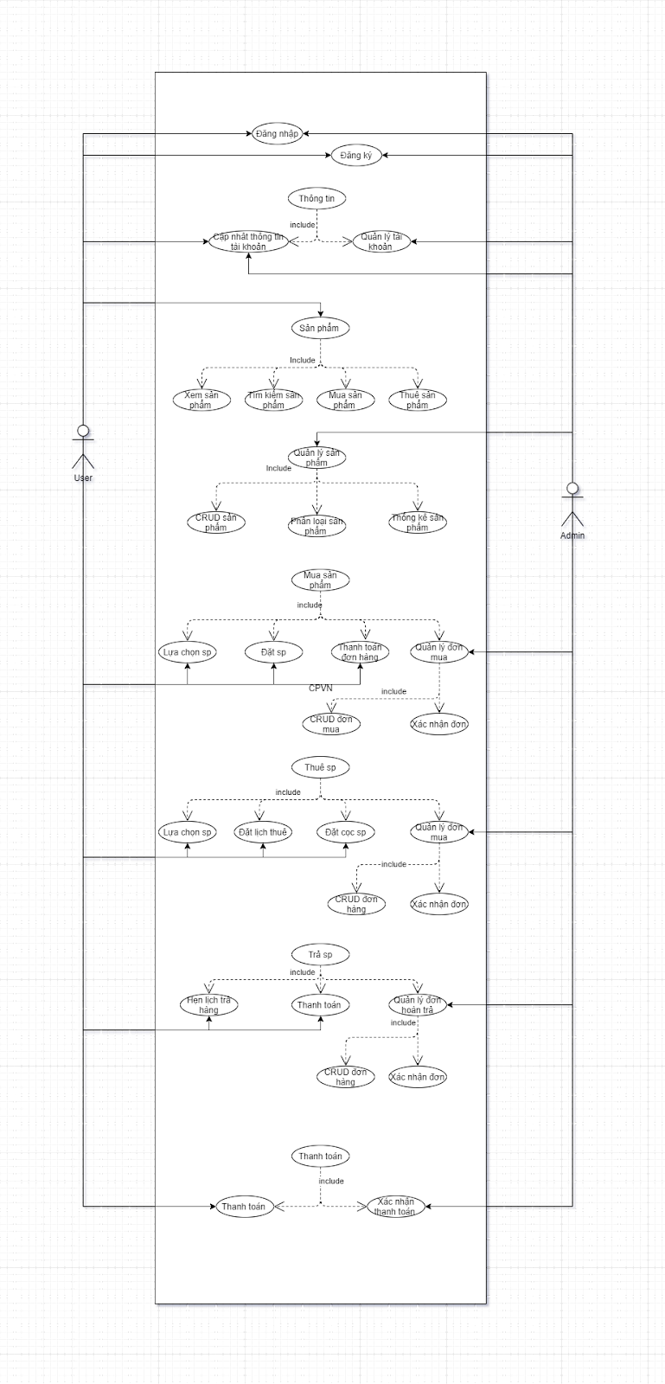

# IV. UI/UX

## Home

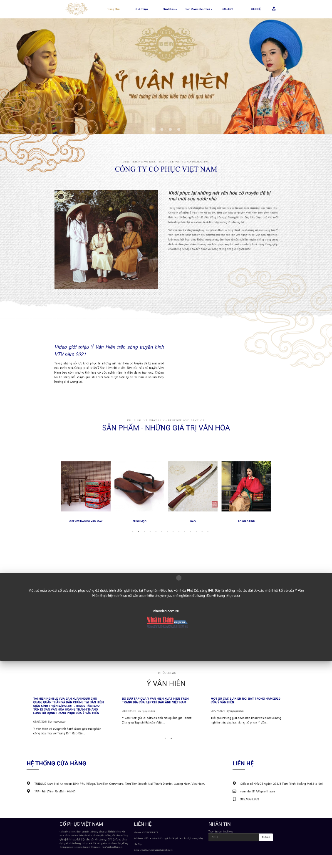

## Introduce

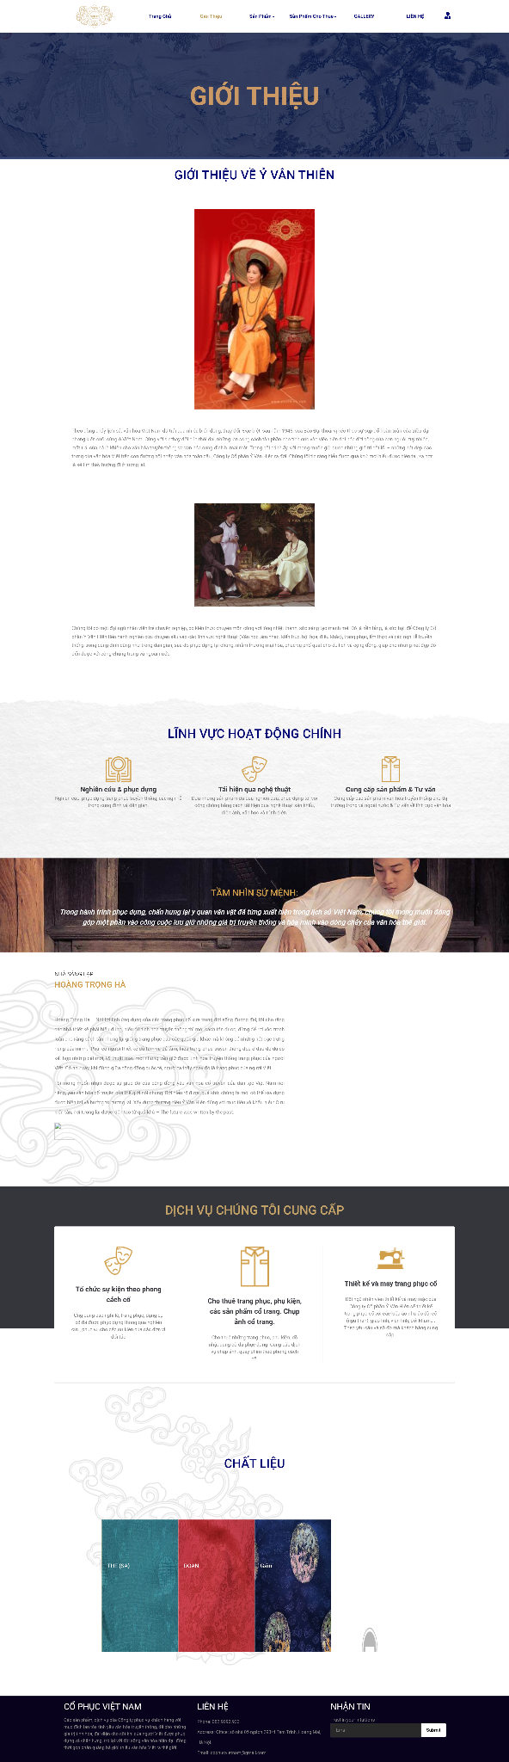

## Product

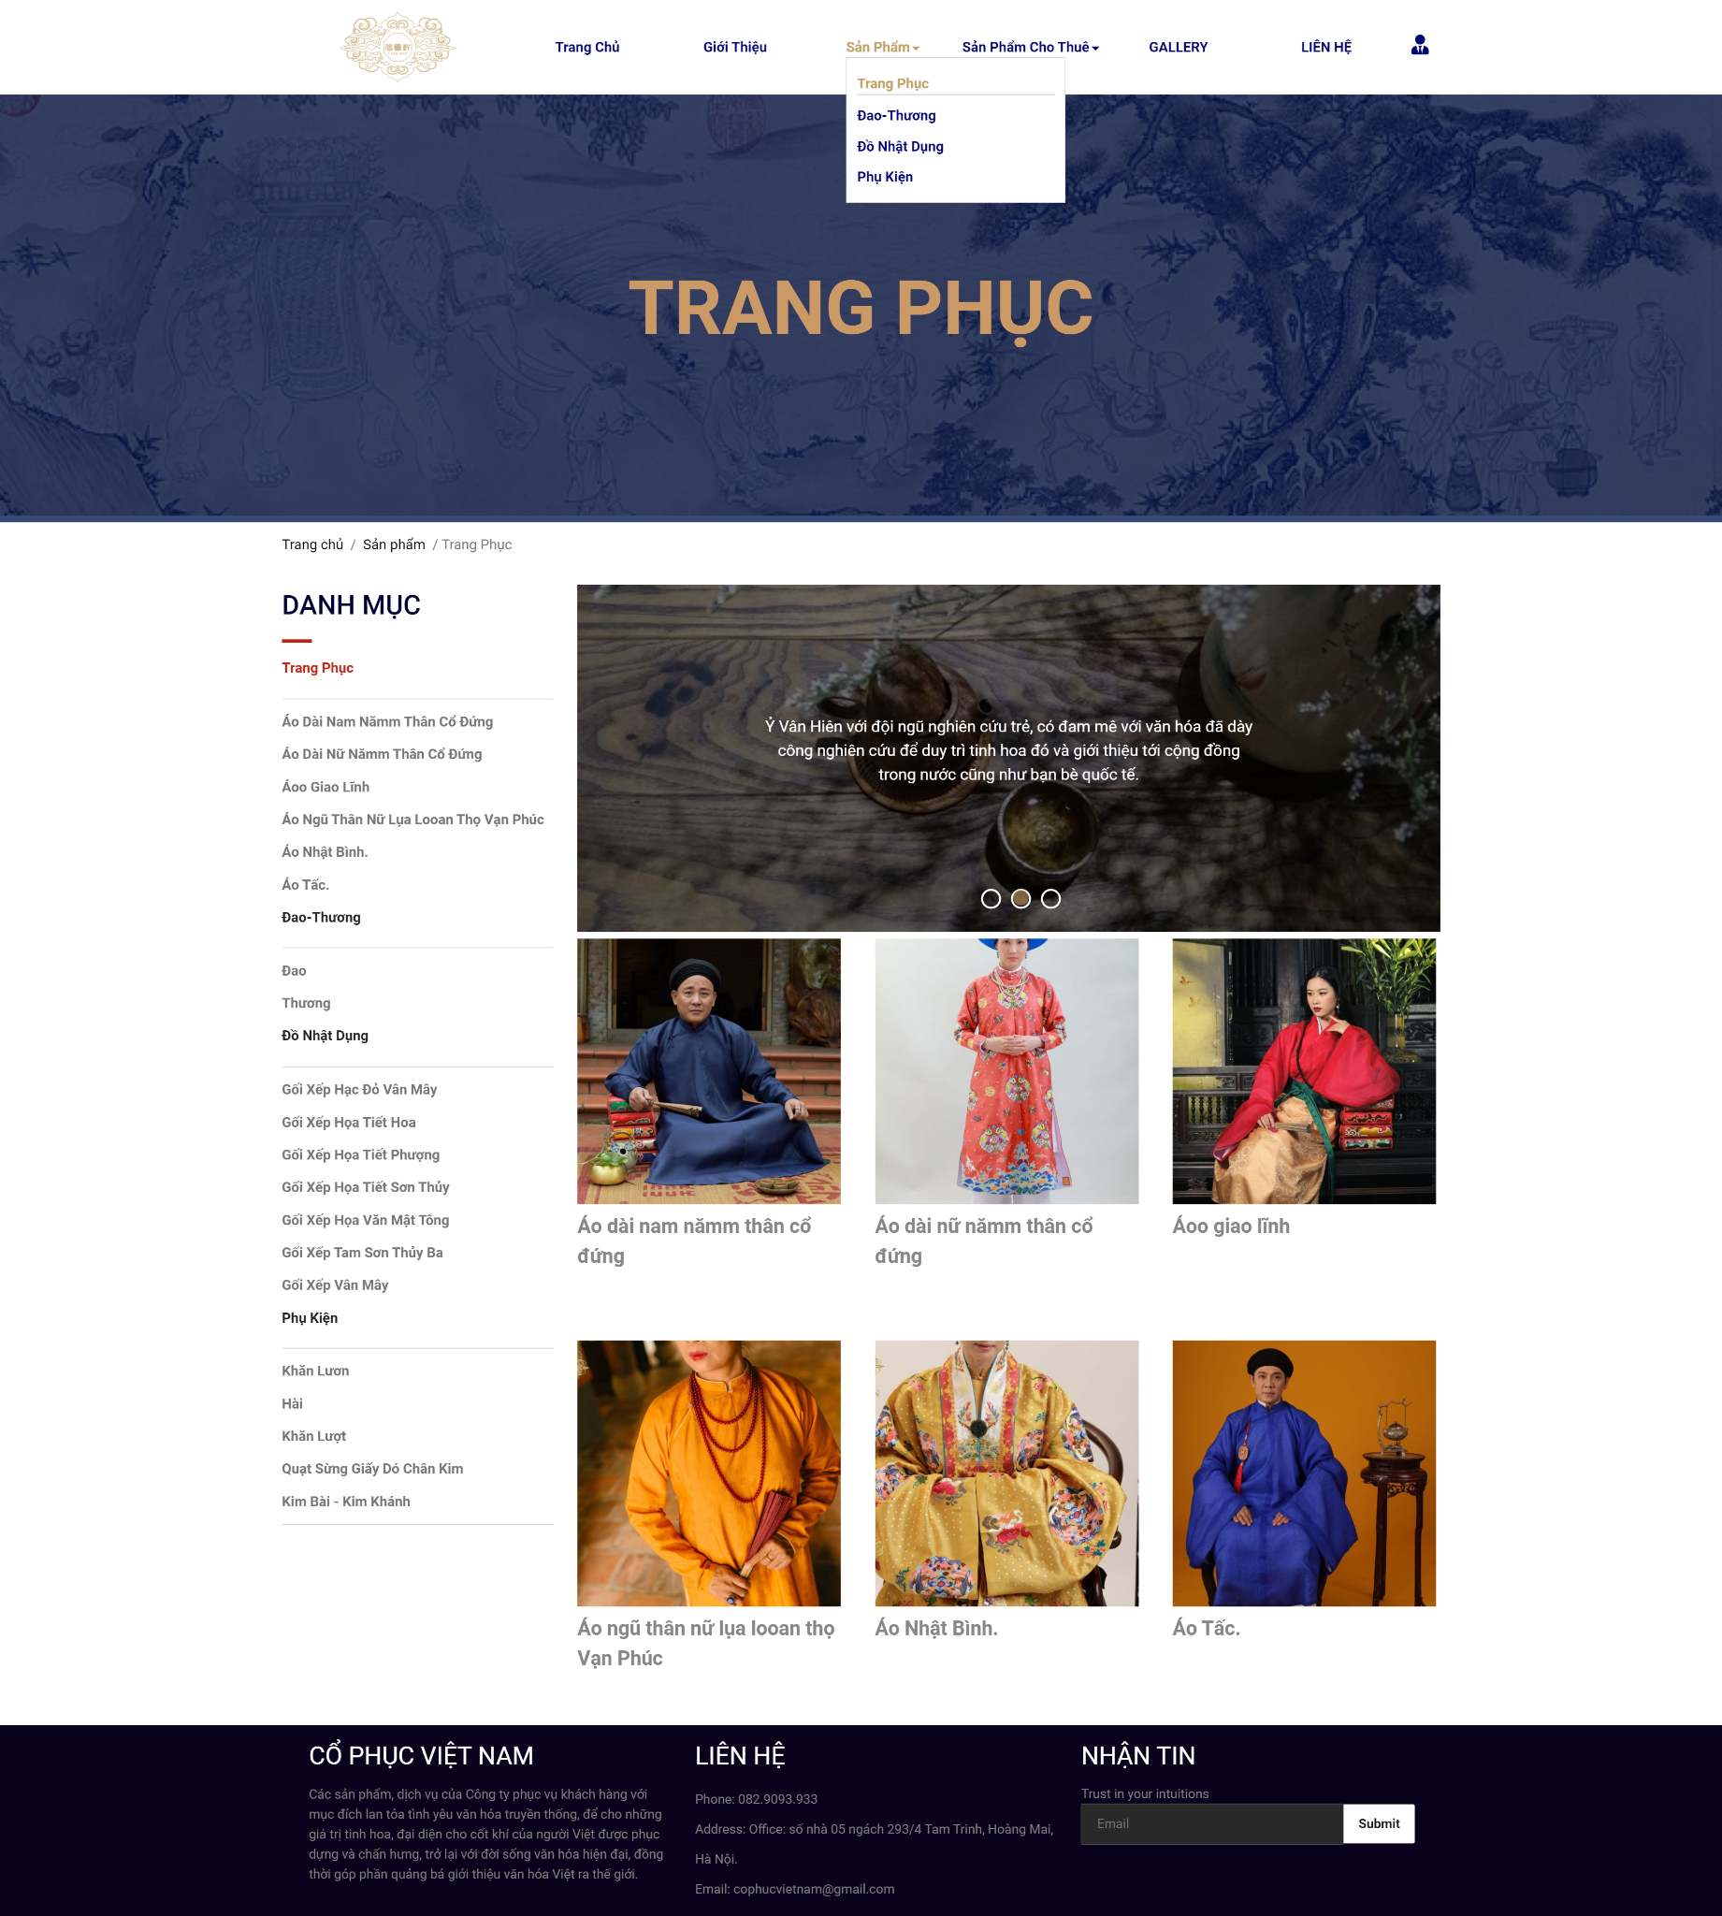

## Contact

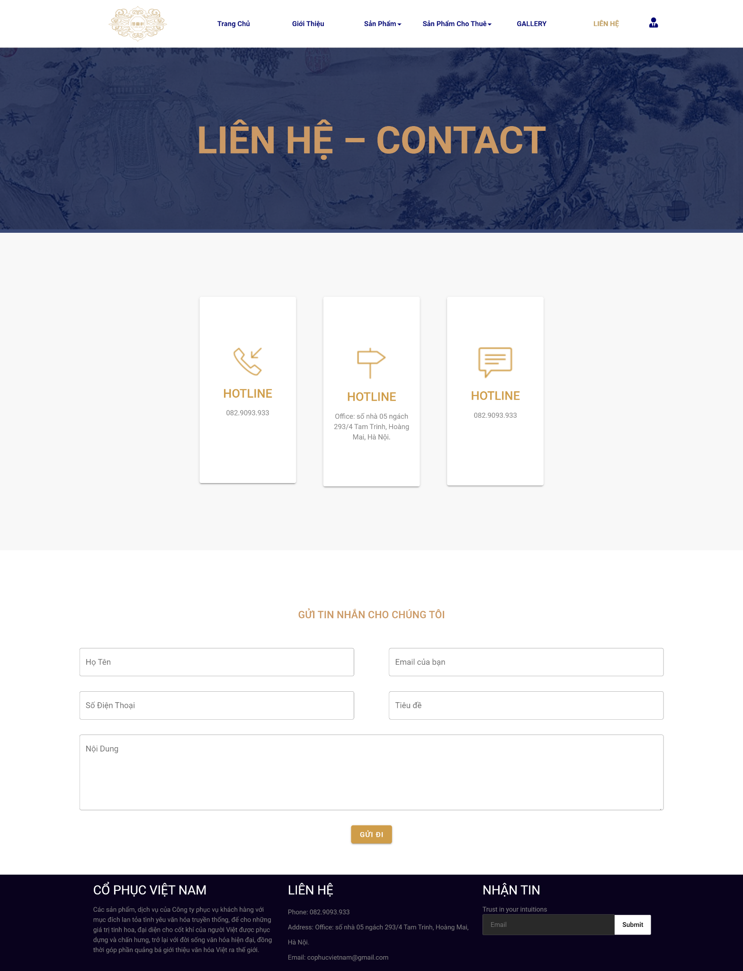

## Payment

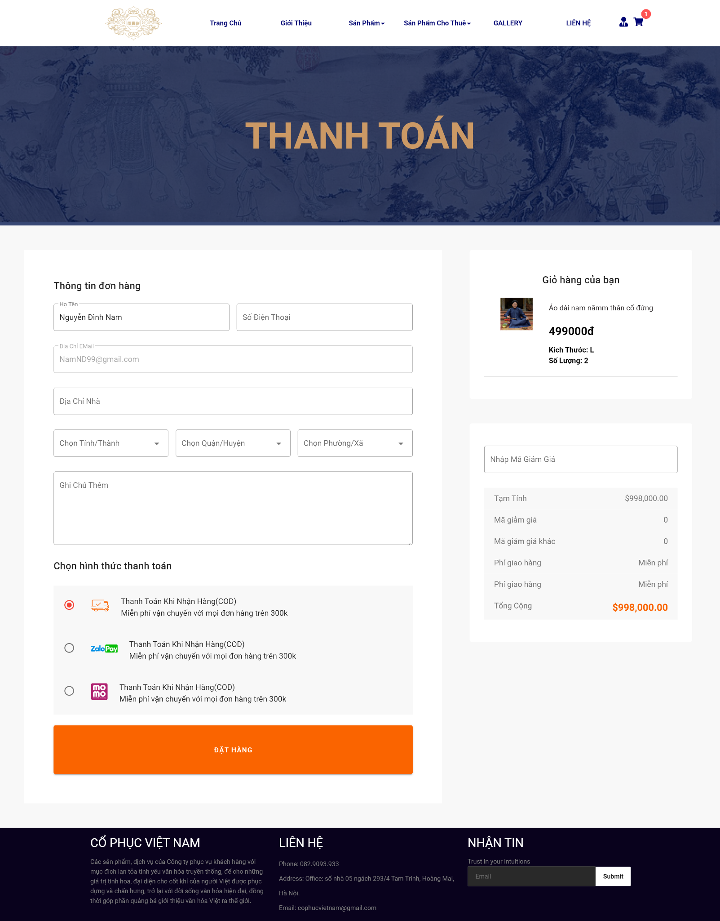

## Customer information

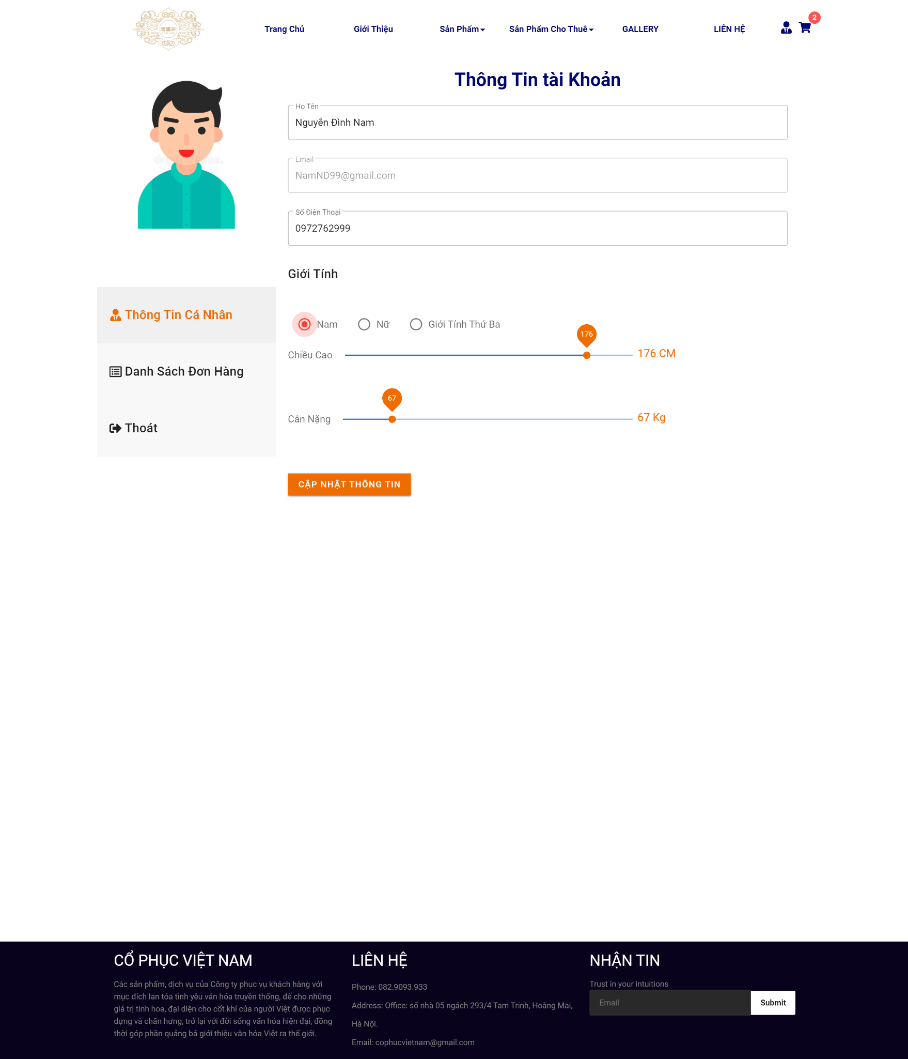

## Cart

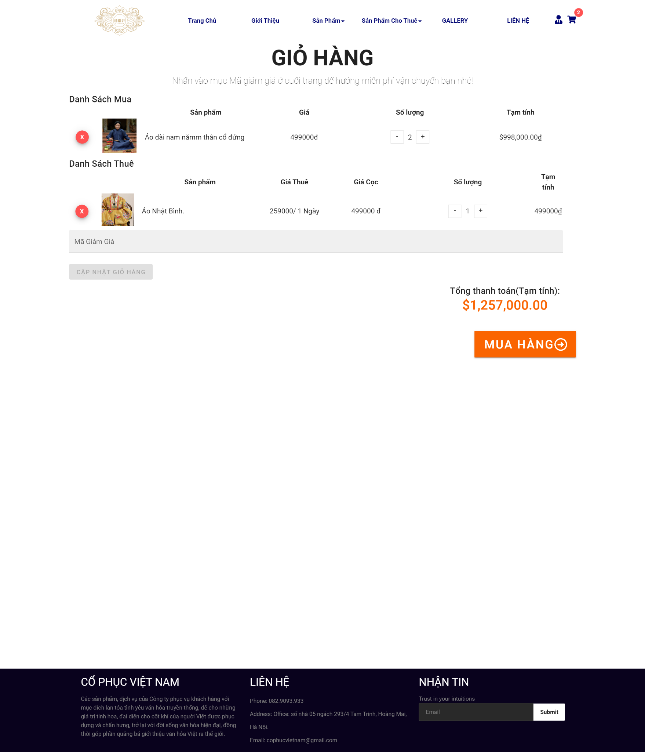

## Order Success

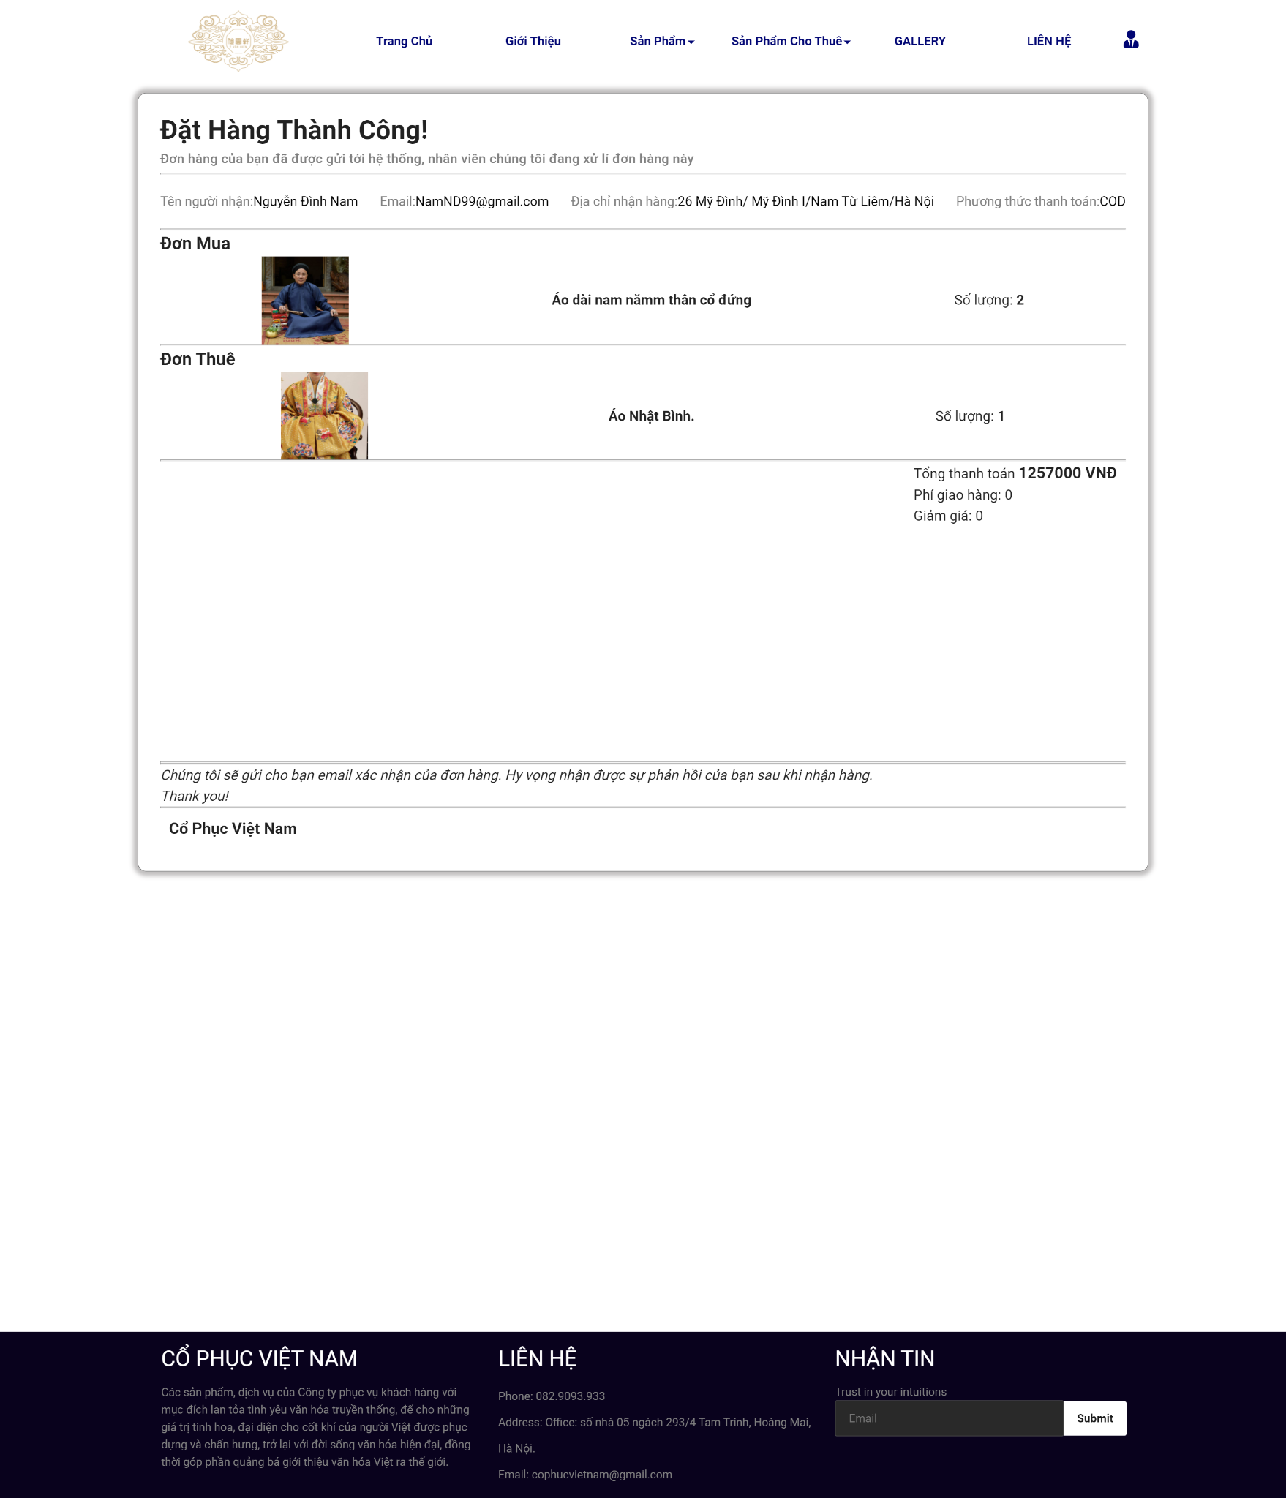

## Order detail

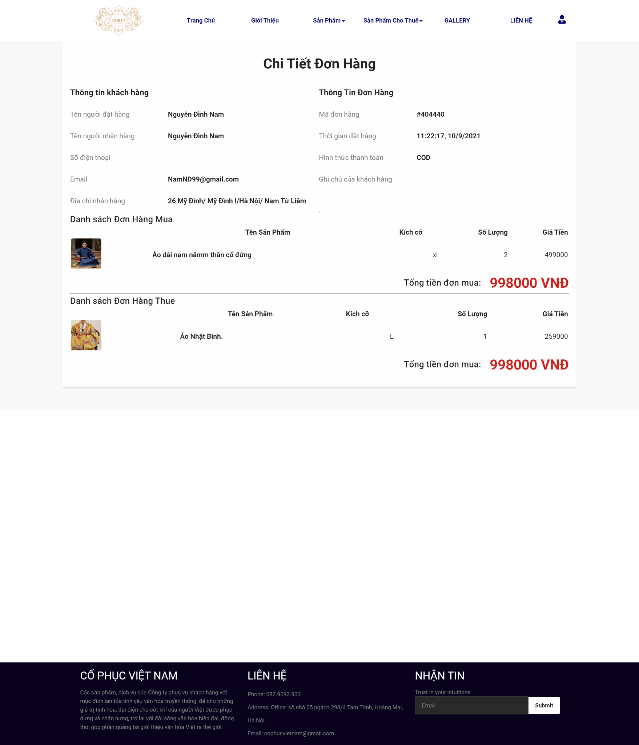

## Gallery & Lookbook

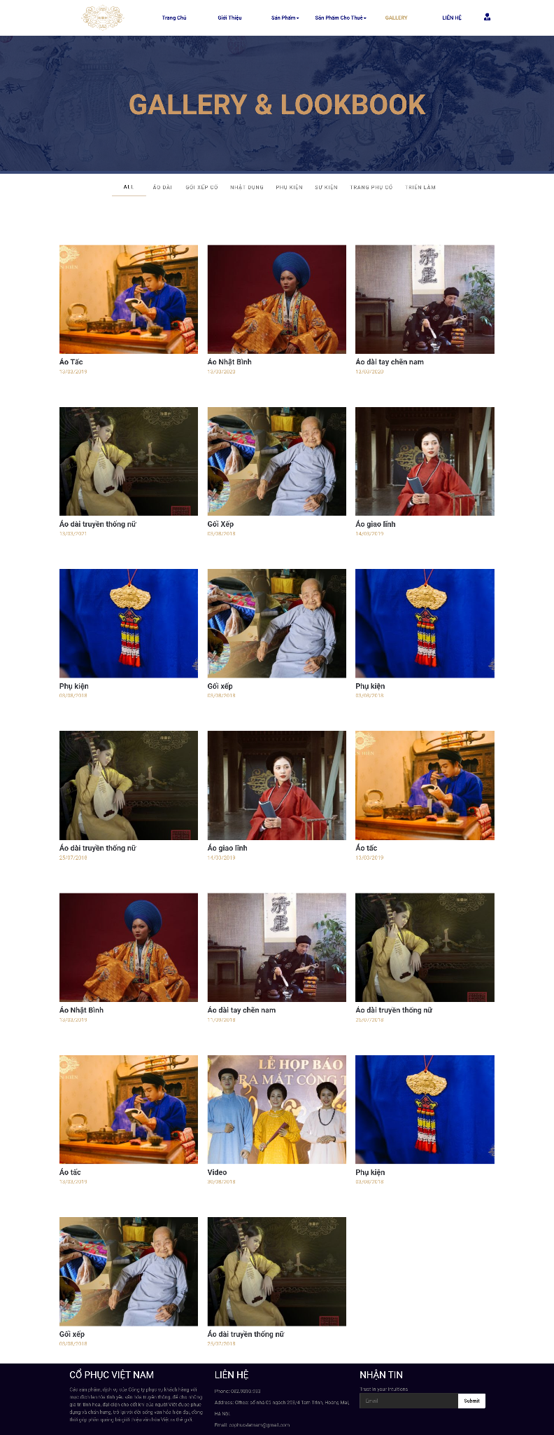

## Admin Dashboard

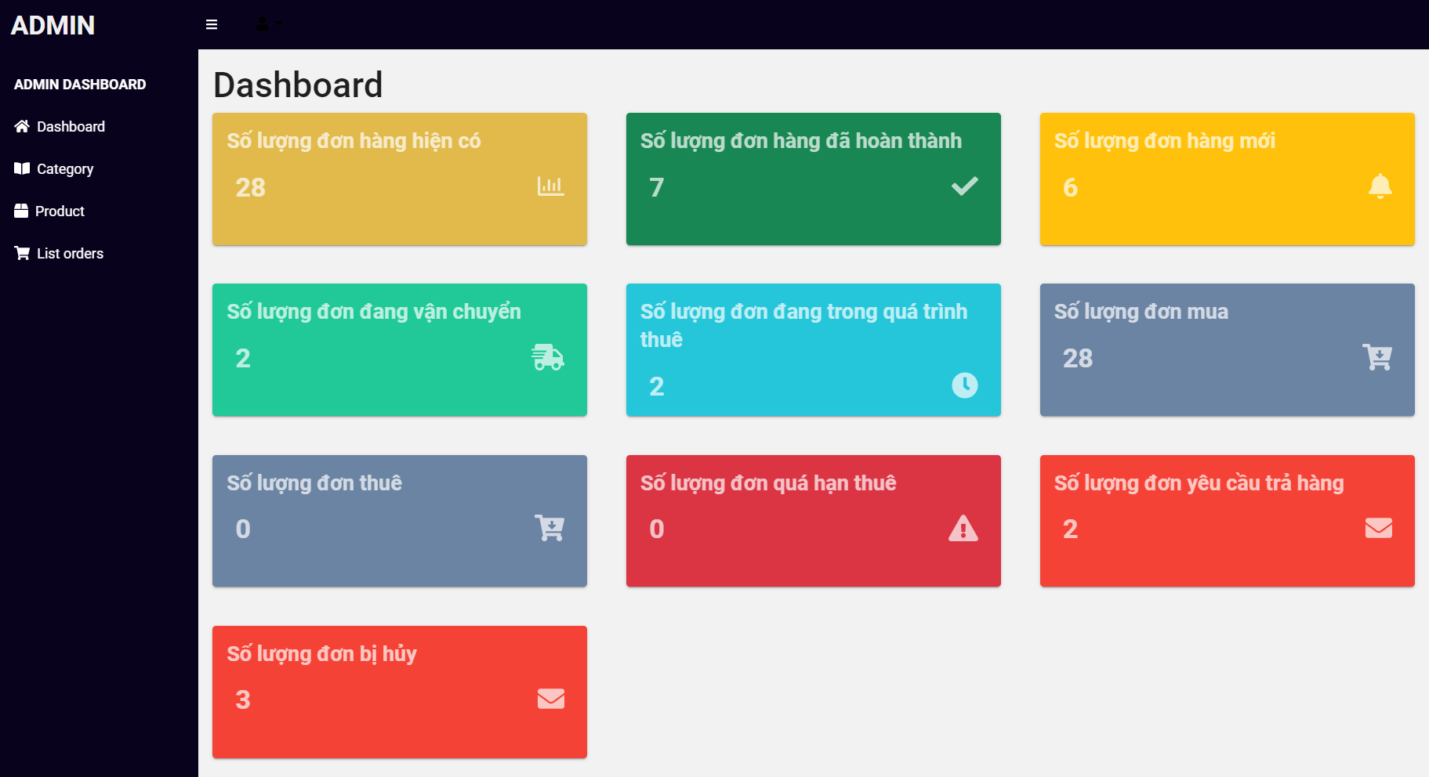

## Admin order detail

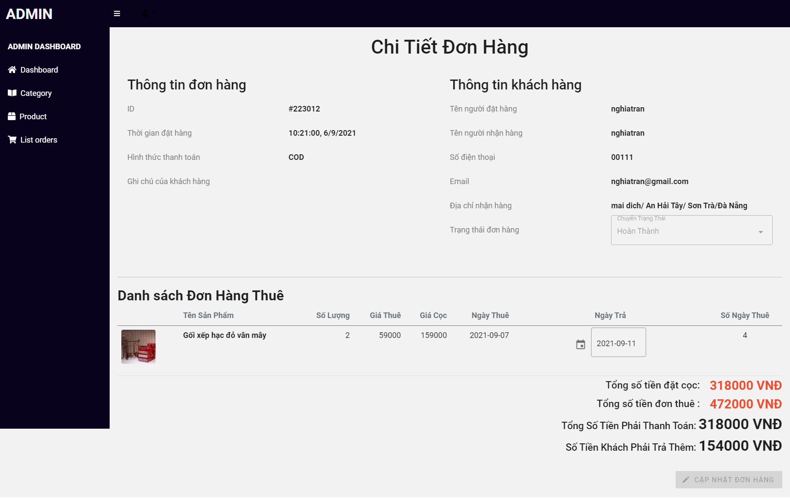

## Admin Product

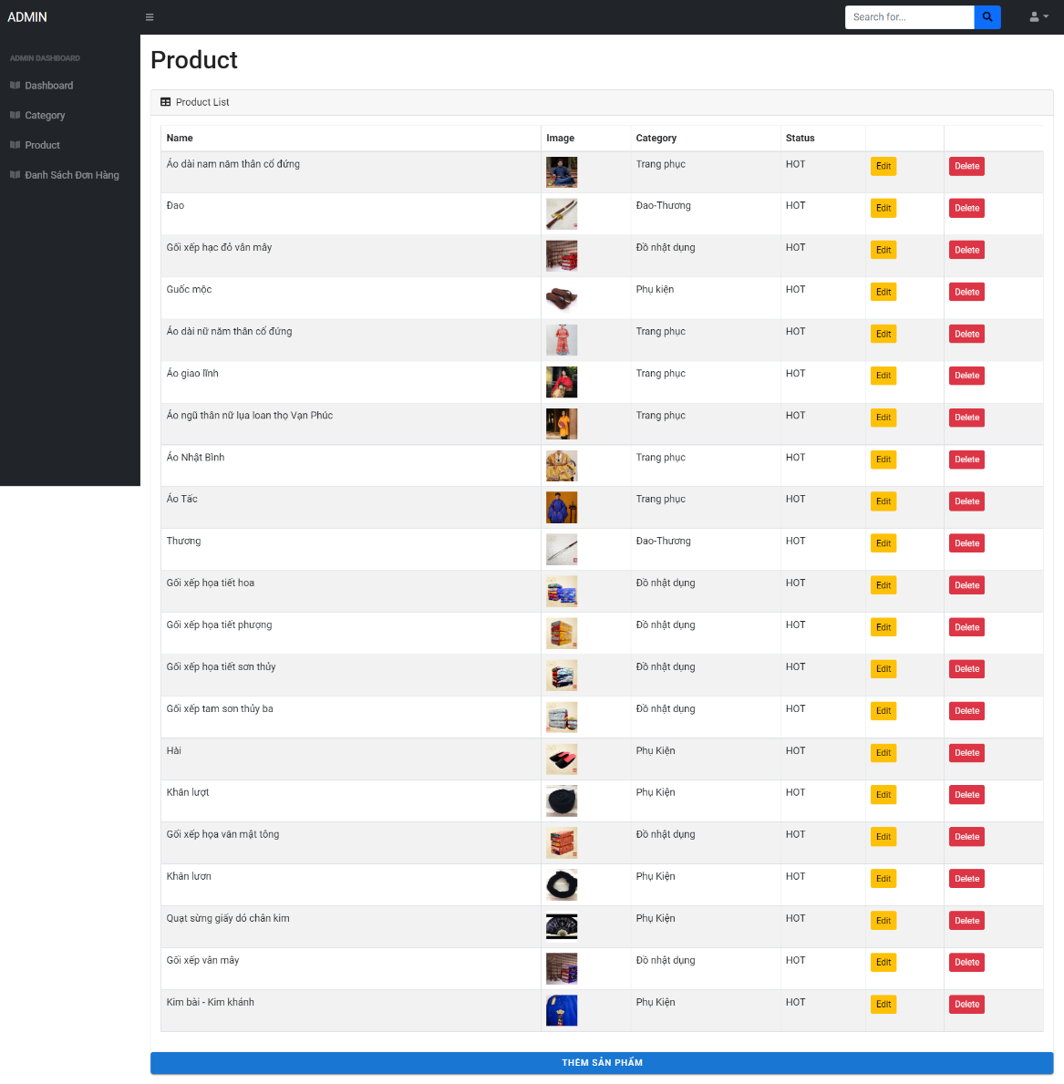

## 

## List order

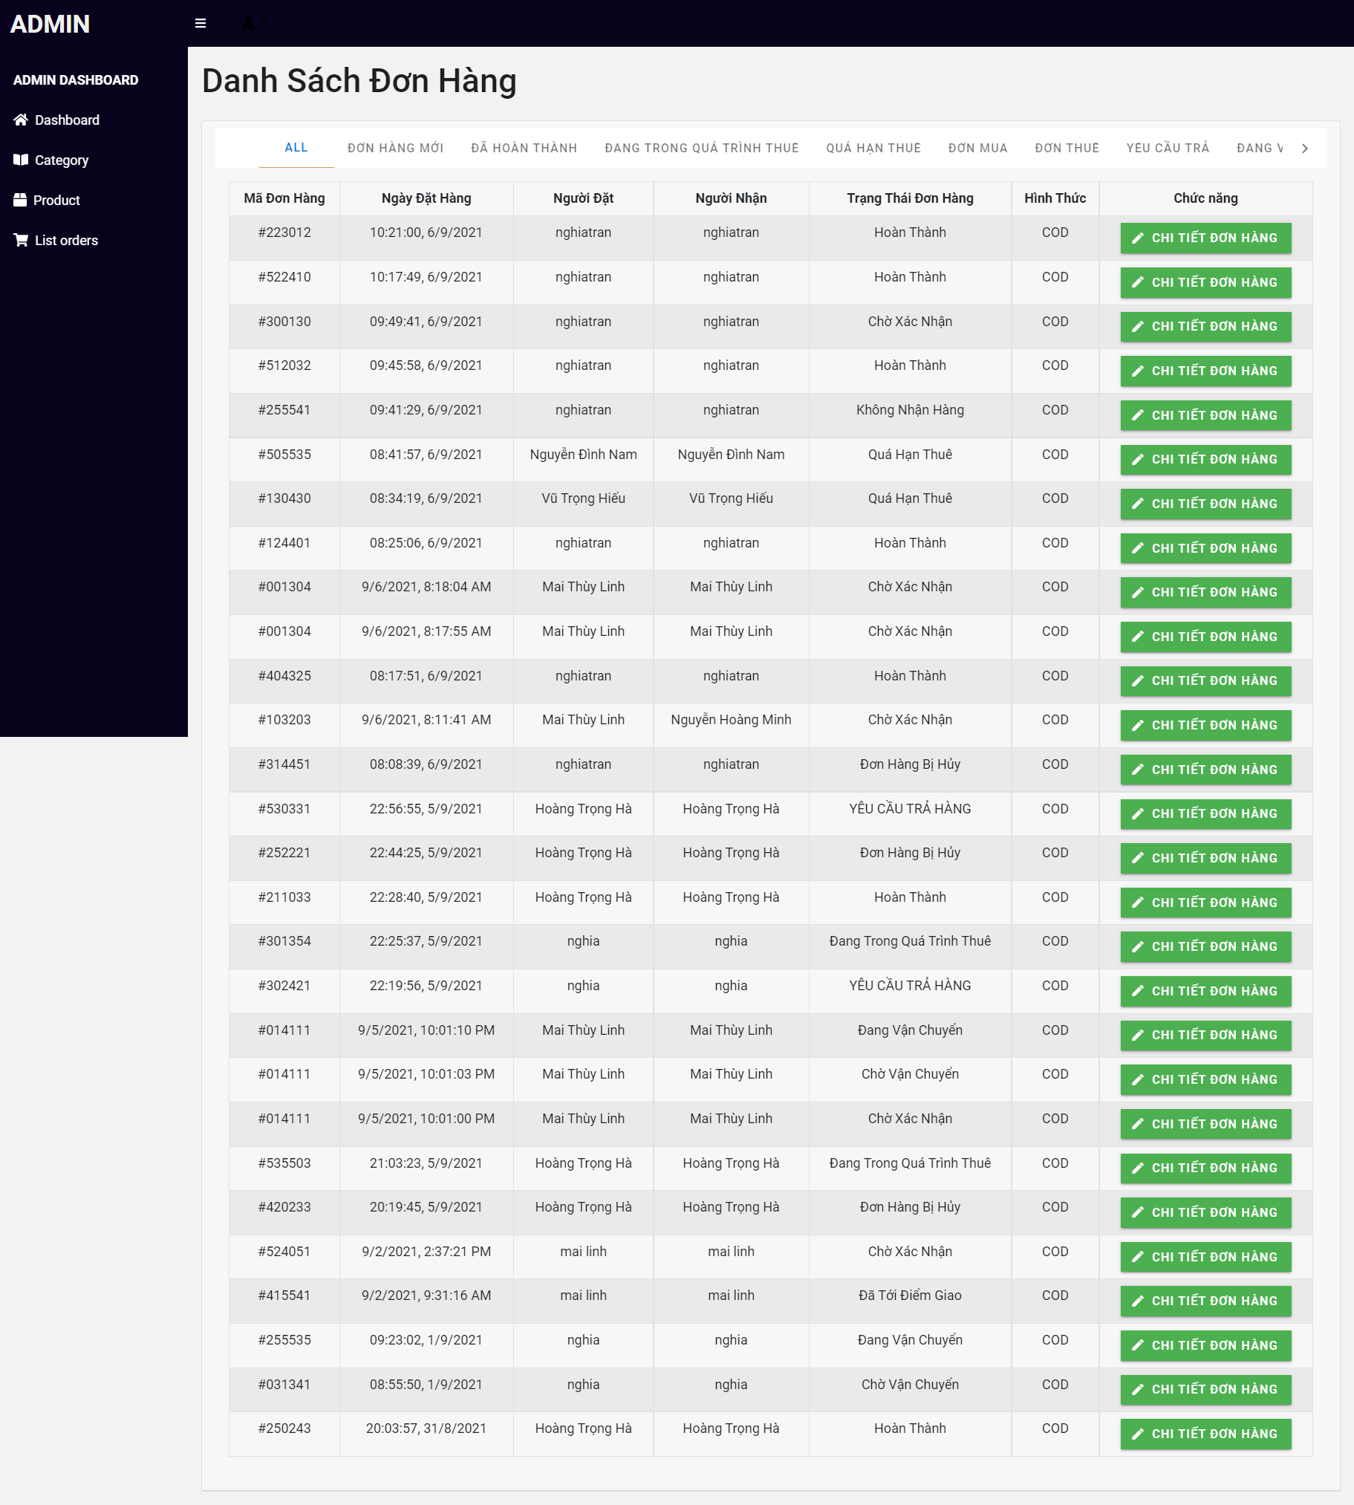

## Categories

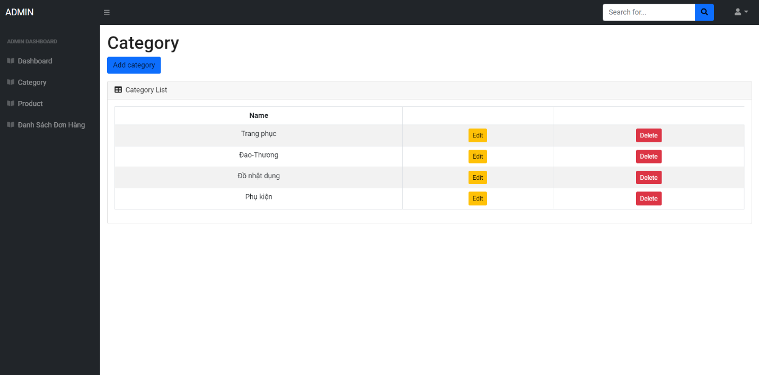

# V. Management and Project Planning

## Management Approach

We choose the Agile Scrum model to develop the project, our team has 5 members, including 1 Scrum Master and 4 Developments. We schedule weekly and 30-minute teamwork every day at 9:30 pm. During the week, there will be a list of tasks listed and divided equally between each person. With each meeting, people talk about the work they have done, have not done, the difficulties they are facing and then offer solutions to overcome and develop further. We listen and support each other throughout the project.

## ProjectPlan

### Product Backlog

### Sprint Backlog

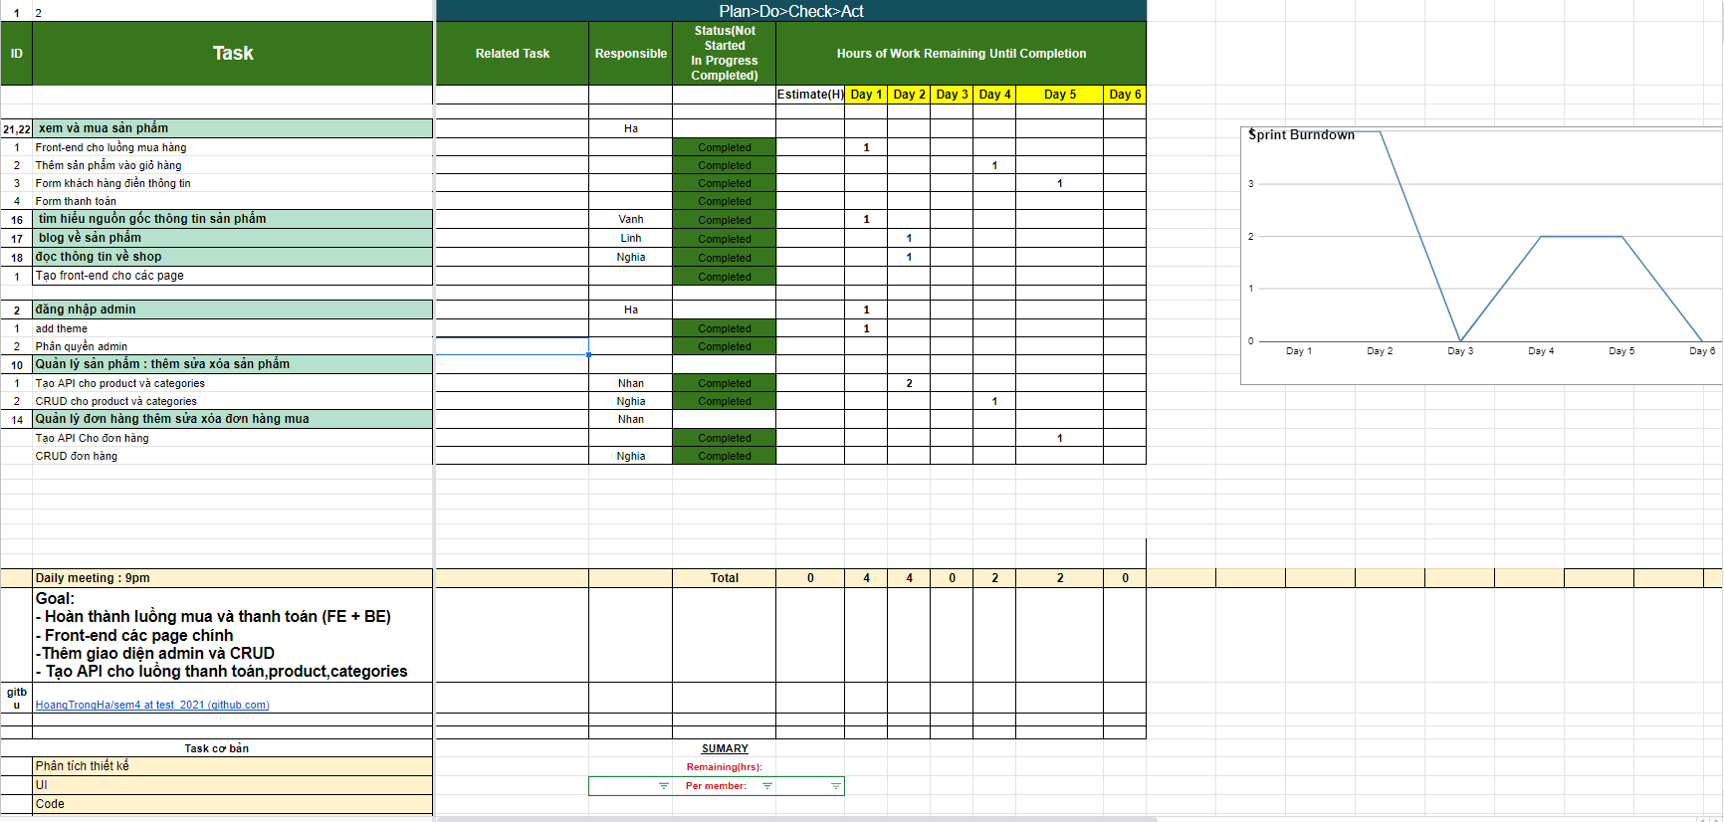

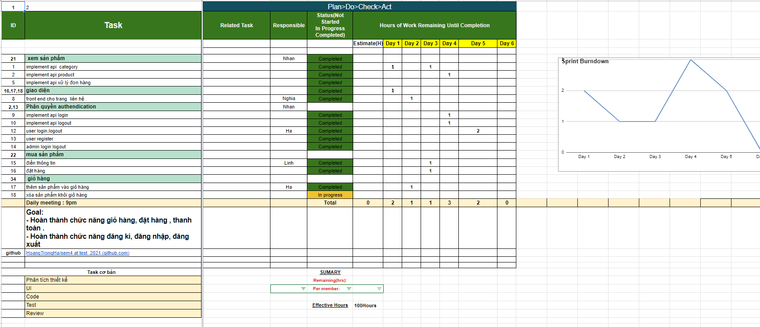

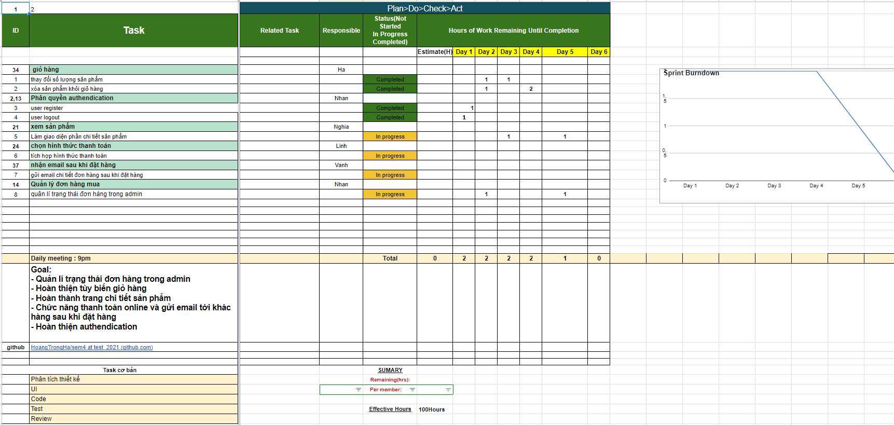

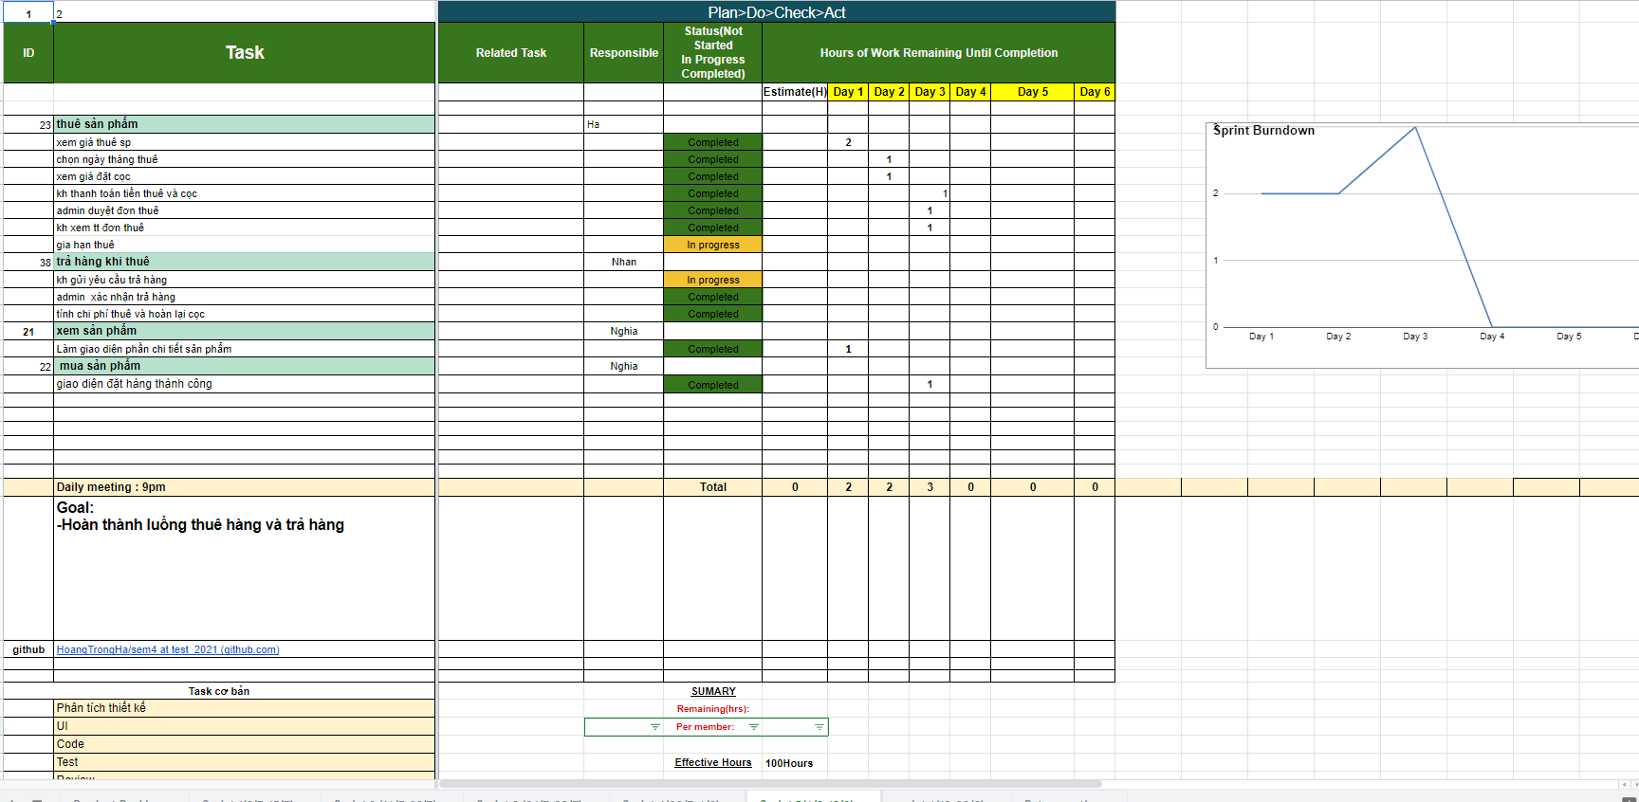

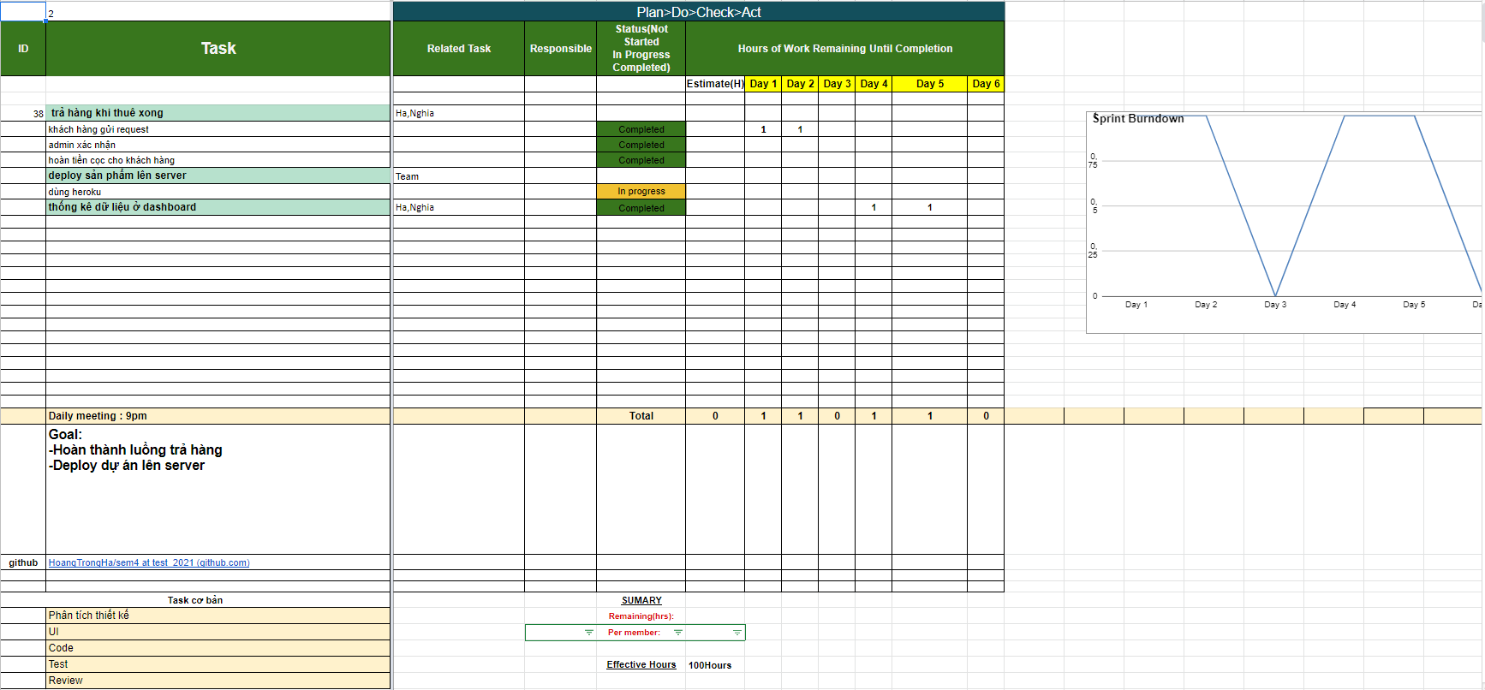

## Retrospective

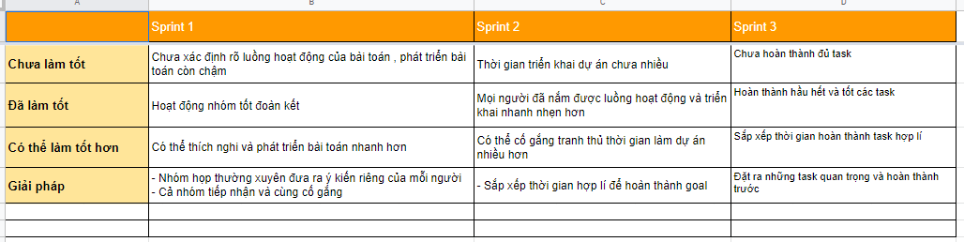

## Meeting minutes

- Before the complicated development of the epidemic, the team members have overcome it by meeting and reporting daily via google meet and skype.

- The time of each meeting starts at 9:30 p.m. daily and usually ends 1 to 2 hours or more later.